SRX-6HC Universal Receiver Specification
SRX-6HU (72 / 41 / 40 / 36 / 35Mhz)
尺寸 | 1.3”x0.75”x0.32”(33x18.9x8.2mm)
重量 | 0.28oz/8.2g (with shrink wrap)
準度 | about 2.0μV
敏銳度 | ±8kHz at 65dB down
動作CH | 1-6
濾波器 | Dual turned RF circuitry
濾波晶體 | Dual 4 element ceramic filter
濾波晶體 | DSP filtering in MCU with mild algorithm
變相頻段 | Positive or negative (auto-detect)
外殼 | Shrink wrap
工作電壓 | 3.6V~11.4VDC
工作電流 | 11mA
水晶體尺寸 | HC-50 (STD)
距離 | 500 m / 1,400’ ft
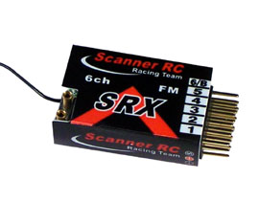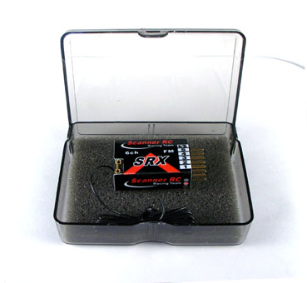
Scanner RC Racing Team

