SRX-8HC Universal Receiver Specification

SRX-8HU (72 / 41 / 40 / 36 / 35Mhz)
尺寸 | 1.4”x0.9”x0.4”(36x22.6x10.3mm)
重量 | 0.38oz/12.4g (with shrink wrap)
準度 | about 2.0μV
敏銳度 | ±8kHz at 65dB down
動作CH | 1-8
濾波器 | Dual turned RF circuitry
濾波晶體 | Dual 4 element ceramic filter
濾波晶體 | DSP filtering in MCU with mild algorithm
變相頻段 | Positive or negative (auto-detect)
外殼 | Shrink wrap
工作電壓 | 3.6V~11.4VDC
工作電流 | 16mA
水晶體尺寸 | HC-50 (STD)
距離 | 1,000 m / 3,200’ ft
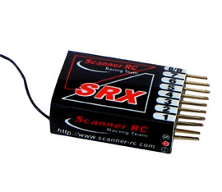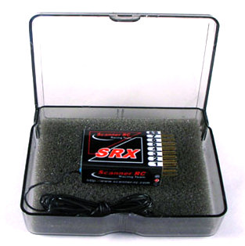
Scanner RC Racing Team

